Appendix A

Virtual New Amsterdam Prototype

Environmental Simulation Center will support the scope of work for the Virtual New Amsterdam Prototype (VNAP) for the New Amsterdam History Center (NAHC). It is the product of series of communications between George Janes, Courtney Haff, and Len Tantillo.

Background
Shortly after the meeting of the experts on New Amsterdam history in December, which validated the concept of virtual New Amsterdam, the Project team met to determine how the NAHC virtual New Amsterdam exhibit should be developed.

Rather than spending a good deal of time and money building all of New Amsterdam, the team determined that a small, but near fully functional prototype of the exhibit should be developed as quickly as possible so that the board and advisory committees could provide feedback on the content, visual appearance and functionality. Once the design is finalized and implemented for the functional prototype, it would act as the foundation of the exhibit, capable of supporting additional portions of New Amsterdam as they came on-line.

The area selected for the VNAP is defined as the highlighted area below:

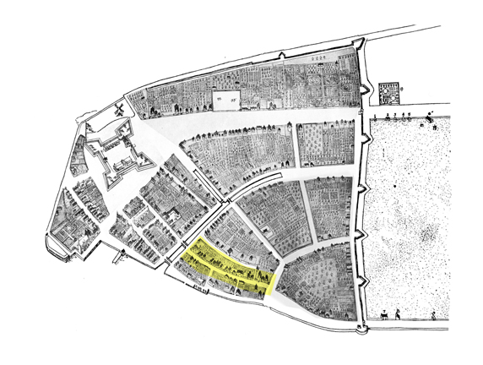
This area is both sides of modern day Stone St. between Old Slip and Broad St. This is the area selected because it is historically interesting, while still being fairly architecturally typical for New Amsterdam

Scope of work
The scope of work is separated into two distinct parts: The first is the development of the digital 3D models of New Amsterdam, terrain, façade textures, gardens, trees and historically appropriate “street furniture” that visually recreate the historic scene. The second is the development of a relational database, human interface, interactive 3D runtime, overview map, and client/server architecture which links 3D models to archival information.

Both portions will draw on the experience of the previous work of Tantillo’s historically inspired art and the Environmental Simulation Center’s previous 3D virtual exhibits.

Part 1: Developing the 3D models
The 3D portion of the VNAP will be developed in the following steps:

- Creation of a 17th century New Amsterdam Material and Texture Library: All surface textures will be hand drawn and digitally colored. These surfaces will include building materials, brick, stone, construction lumber, thatch, pan tiles, glass etc. and natural materials grass, bark, leaves, gravel, garden vegetation etc.

- Digital Models for Predefined Residential Sites: Approximately 30 models representing objects in the residential area described above will be modeled. These objects will include houses, barns, sheds, outbuildings, fences, the ground plane, gardens and others.

- Fitting Textures and Structures: The material library will be used to develop and fit appropriate textures to the digital mesh models, creating a complete and renderable building site and its immediate surroundings. Also structures will be so located as to reflect the general layout of the Castello Plan.

The texture library and some of the houses will be developed to be reused elsewhere in virtual New Amsterdam once the project moves beyond the protype area.

Part 2: Developing the technical architecture
A technical infrastructure and human interface for the 3D model of New Amsterdam will be developed for the prototype. The interface and the database will be an interesting and engaging exhibit that will be used to both walk through the 3D model and query and access the historical archives. The technical infrastructure built during this phase will be the foundation upon which the final exhibit is built.

We propose developing this interface as follows:

- The 3D runtime: A 3D runtime will allow users to move through the 3D model created in Part 1 and interact with objects in a 3D scene. This 3D runtime will allow both freedom of movement and also support pre-recorded tours that allow users to freely look around, but stay on a pre-determined path. Objects within the 3D scene will also support links and audio that would allow users to listen to guided tours or follow hyper-links to internal or external websites.

- The overview map: A window within the interface will support an overview map, which will help keep the user from getting lost in the 3D scene. While most likely unnecessary for this small prototype, the map will still be functional and will be designed to be expanded to include GIS information from other eras to allow the possibility of relating specific places and events in 1660 Manhattan to current conditions.

- The database: The archival database will be a relational MySQL database. A database schema, uploading and interface scripts will be developed to support maintenance and querying. Scripts will be support the client/server architecture (e.g. PHP, Java, JavaScript) and multi-user modes. The database will be populated with enough information to show design functionality, but it will not be fully populated with archival information for the prototype.

- The Human-Computer Interface: The human computer interface to the 3D information will be captured within the runtime environment. Most of the interaction will be through a mouse within the scene or to set options. The interface to archival information will be developed in Flash, Java, HTML or other standard that supports client/server technology. It will be designed to support both professional users’ queries and casual users’ non-hierarchical exploration.

- The technical architecture: While it is still in the prototype phase, Virtual New Amsterdam is expected to exist on a stand-alone machine. Its architecture will be built using client/server technology, however, and function using a web server (Apache). In the case of the prototype the same machine will function as both the client and the server. This technology architecture will allow an easier transition to the web--should the exhibit eventually be put on the web as expected--or to support multiple users within the facility itself.

The VNAP system would be then installed on the NAHC computers and training on use and updating would be provided. Developed as a fee-for-service (rather than licensed application) the VNAP would be an asset that the NAHC can modify and even assign to another party.

