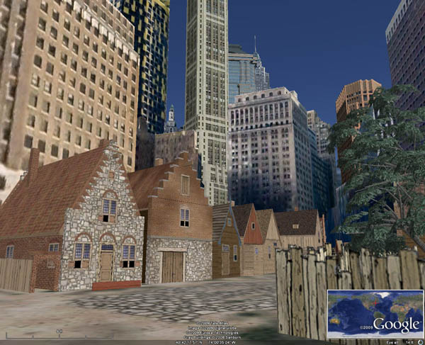
New Amsterdam History Center’s Virtual New Amsterdam Prototype

The Virtual New Amsterdam Prototype was created by the Environmental Simulation Center (ESC) in collaboration with Len Tantillo, Hudson Microimaging and Haff Associates, Inc. for the New Amsterdam History Center (NAHC) with funding from the New York Empire State Development Corporation and the Collegiate Church Corporation.

The prototype was conceived as a "proof of concept," demonstrating the capacity to deploy an online virtual 3D environment that can be used to explore the "sense of place" of New Amsterdam in the 17th Century. Once developed, the model will serve as an educational tool for students and teachers of New Amsterdam history.
The emphasis of the model is on creating a sense of daily life in the Dutch settlement and connecting the physical environment to historical documents and research. The prototype focuses on Stone Street and includes 28 buildings modeled by noted historical painter Len Tantillo, as well as a garden and an interior modeled by ESC, featuring typical 17th Century Dutch objects that might have belonged to a resident of New Amsterdam. The model also has a lively street scene of people engaged in everyday activities drawn from 17th Century Dutch Paintings.
The application was developed using Google Earth and the Drupal open source content management system. It offers a spatial framework that can house knowledge about the settlement as it is currently understood. Potential connections between the 3D Model of the settlement and present-day Lower Manhattan, as well as database and external websites such Wikipedia, situate it within the context of current historical, curricular, ancestral, archeological, geological and other forms of research.

The following images offer a glimpse of the prototype in its current phase, including: a view of the whole prototype area from the Castello Plan, an eye-level streetview, the interior of a farmhouse on Stone Street, and the underlying Drupal database.

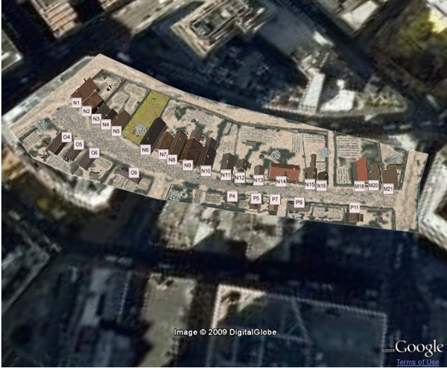

Castello Plan View
The opening view of the prototype is an aerial perspective, modeled on the Castello Plan, an early map of New Amsterdam, created by the surveyor, Jacques Cortelyou. Each tax lot is tagged with a number corresponding to its description in I.N. Phelps Stokes' Iconography of Manhattan Island. Clicking on a tag links the user to the database containing corresponding information about the tax lot, including the use of the tax lot (i.e., brewery, mill, house, etc.) and the related ancestors, as well as a PDF of the tax lot's listing in the Stokes Iconography and other related resources.

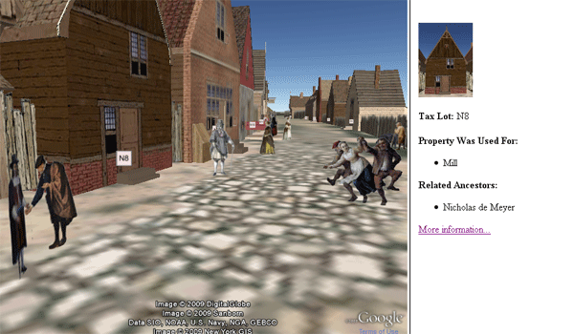

Eye-Level View
A user can select "Eye Level" view to virtually walk down Stone Street to gain a sense of daily life in the Dutch settlement. On the way, users encounter figures extracted from 17th Century Dutch paintings, and can visit a fully modeled period garden based on Joel Grossman's Human-Landscape Interventions in the 21st Century. Users can also peek into the window of a tavern and see the lively scene inside. Tax lots are displayed and clickable, so that users can click between the 3D model and the database.

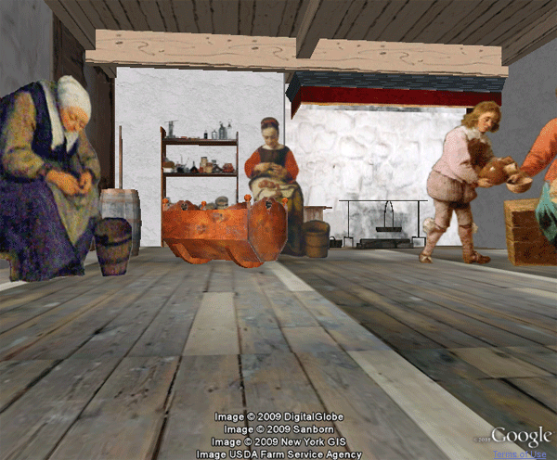

Farmhouse Interior
The modeled farmhouse interior can be accessed by clicking the label on the top of the screen, or by walking in from Stone Street. The interior features everyday objects such as a barrel, a cradle and a hearth modeled in 3D based on photographs from the Wyckoff Farmhouse Museum and other sources. The user can visit New Amsterdam residents engaged in domestic activities, further enhancing their sense of daily life in the settlement.

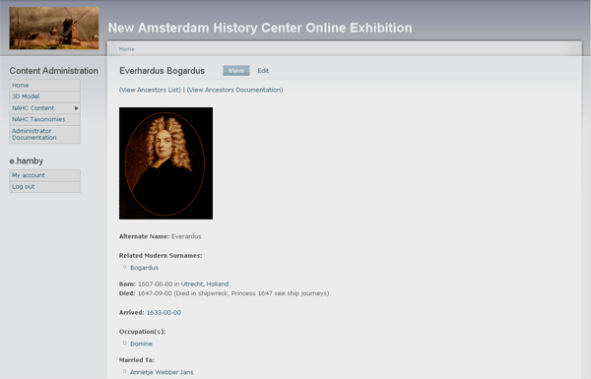

Database View
The Drupal database that is connected to the 3D model contains linked information about the people and places of New Amsterdam. The database allows users to deepen their understanding of the settlement by learning more about specific inhabitants, occupations and property types.

The NAHC expects to complete the full 3D imagery of New Amsterdam in the 1660 period and incorporate it into the New Amsterdam History Center On-line Exhibition by July 31, 2010.
Additional information on the project is available at: http://www.newamsterdamhistorycenter.org/ .

Questions or comments regarding the Virtual New Amsterdam Prototype, or if you wish to be a member of the project’s user group, please email us at nahc.vnap@gmail.com .

