Bottom of Form
BGC

Main Gallery

Dutch New York Between East and West: The World of Margrieta van Varick
September 18, 2009 to January 3, 2010

This autumn the Bard Graduate Center will participate in a state-wide celebration of the 400th anniversary of Henry Hudson's voyage and the legacy of Dutch culture in New York with a landmark exhibition, Dutch New York Between East and West: The World of Margrieta van Varick. Organized by the BGC and the New-York Historical Society and curated by Marybeth De Filippis and Deborah L. Krohn, Dutch New York will make a major contribution to the quadricentennial and to the scholarship of colonial New York by focusing on the life and times of a woman who during the seventeenth century lived in the rural village of Flatbush on eastern Long Island, a neighborhood still known by that name in the borough of Brooklyn today. The exhibition helps elucidate what the historian Russell Shorto has called the "forgotten colony" in his book The Island at the Center of the World. Indeed, the British roots of New York City are recognized far more widely than the Dutch, despite the city's visible connections to the Dutch founders, most evident in street names such as Amsterdam Avenue and Varick Street.
Scroll upScroll down
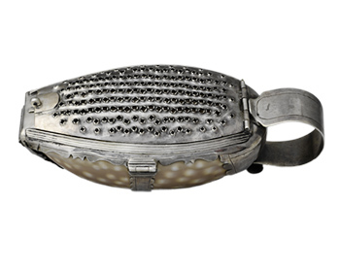

Nutmeg Grater

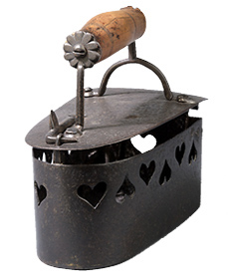

Iron

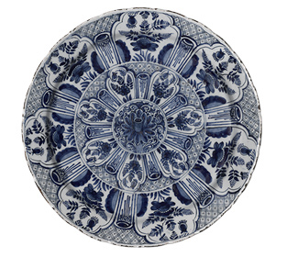

Dish

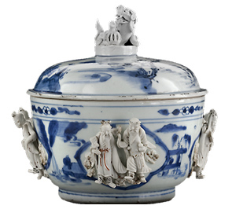

Covered Bowl

- The Exhibition

Dutch New York Between East and West: The World of Margrieta van Varick
September 18, 2009 to January 3, 2010
This autumn the Bard Graduate Center will participate in a state-wide celebration of the 400th anniversary of Henry Hudson's voyage and the legacy of Dutch culture in New York with a landmark exhibition, Dutch New York Between East and West: The World of Margrieta van Varick. Organized by the BGC and the New-York Historical Society and curated by Marybeth De Filippis and Deborah L. Krohn, Dutch New York will make a major contribution to the quadricentennial and to the scholarship of colonial New York by focusing on the life and times of a woman who during the seventeenth century lived in the rural village of Flatbush on eastern Long Island, a neighborhood still known by that name in the borough of Brooklyn today. The exhibition helps elucidate what the historian Russell Shorto has called the "forgotten colony" in his book The Island at the Center of the World. Indeed, the British roots of New York City are recognized far more widely than the Dutch, despite the city's visible connections to the Dutch founders, most evident in street names such as Amsterdam Avenue and Varick Street.
Dutch New York offers an innovative approach to exhibition practice by using the probate inventory of Margrieta van Varick's possessions compiled in 1696 as a means of examining life and culture in colonial New York. Born in Amsterdam in 1649, Margrieta spent several years at the other end of the Dutch colonial world in the Far East, primarily in Malacca (present day Malaysia) before returning to The Netherlands with her minister husband Rudolphus. In 1686 Margrieta and her family crossed the Atlantic to settle in Flatbush where Rudolphus was minister of the Dutch Reform Church and where she opened a textile shop, having brought with them an astonishing array of Eastern and European goods.
This exhibition is organized in five sections, each delineating a theme relevant to Margrieta van Varick's life as well as exploring the wide range of goods in her possession when she died in late 1695. The exhibition first examines the inventory as a document of historical research and curatorial practice. A digital film features an interview with renowned historian Natalie Zemon Davis in which she considers the various challenges confronting historians who use inventories for research purposes, as well as the role of women in the seventeenth century.
Next, in a section called "Trading Places," the exhibition examines the network of Dutch trading colonies in the East, particularly Malacca and Batavia (present day Jakarta, Indonesia). These are locations where Margrieta and her relatives lived and where she may have obtained some of the goods cited in the inventory. Of particular interest is the way in which Margrieta's life parallels the history of the Netherlands during the 17th century when an ever-expanding network of global trade and exchange fostered an expansion of wealth and culture amongst the Dutch.
Narrowing the curatorial lens to focus on the Dutch presence in North America, the exhibition subsequently considers "Dutch New York." This section of the exhibition considers the history of the Dutch colony and the continuing strength and persistence of Dutch culture under English rule. When Margrieta van Varick arrived in 1686, New Netherland had already been New York for over two decades. The antagonisms toward the English that culminated in the Leisler Rebellion and the realities of how the Dutch preserved a distinct way of life under English rule were central to the experience of Margrieta and her family and thus provide an important frame of reference for the exhibition. Here visitors will come to understand the economic and religious life of the village of Flatbush, the central role of the Dutch Reformed Church, the connections with Native Americans, and political implications of the Revolution of 1688 in England.
The fourth section of the exhibition is devoted to representations of the many goods described in the 1696 inventory-furniture, metalwork, textiles, costume, and ceramics-and to an exploration of the reasons such goods would have been in the possession of a minister's wife and shopkeeper residing in Flatbush at that time.
In the final section, the exhibition addresses Margrieta van Varick's legacy by focusing on her descendants, including those for whom Varick Street in downtown Manhattan and Willets Point in Queens are named. Of particular importance was the marriage in 1711 of Margrieta's daughter Cornelia Varick to Peter van Dyck (1684-1750), the acclaimed American silversmith. This familial connection to Van Dyck introduces the possibility that Margrieta's possessions may have had an impact on the later history of American decorative arts.
Dutch New York presents approximately 170 objects on loan from public and private collections in the United States and The Netherlands. One third of the objects come from the collection of the New-York Historical Society; other lenders include the J. Paul Getty Museum, the Rijksmuseum, the Amsterdams Historisch Museum, the Museum of the City of New York, The Metropolitan Museum of Art, the American Museum of Natural History, the Brooklyn Museum, Yale University Art Gallery, and the Peabody Essex Museum, among others.

Checklist for the Exhibition

- Highlights
- Interpretation
- Education
- Catalogue
- Online Features
© Copyright 2009, Bard Graduate Center: Decorative Arts, Design History, Material Culture. All rights reserved.

Inventory
The exhibition begins with the display of Margrieta van Varick's estate inventory manuscript, a rare and fascinating survivor from the end of the seventeenth century which serves as the basis for the exhibition. A film in this section features an interview with the renowned historian Natalie Zemon Davis in which she considers the various challenges confronting historians who use inventories for research purposes, as well as the role of women in the seventeenth century.
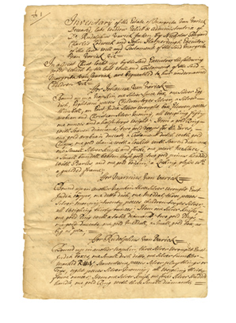

"Inventary of the Estate of Margrita Van Varick Deceased, late widdow relict & administatrix of Do. Rudolphus Varick taken by Nicholas Bayard, Charlis Lodwick and John Harperdingh Executors of the last will and Testament of the said Margrita Van Varick"
Appraisers appointed January 7, 1696; inventory registered January 19, 1697
Pen and ink on laid paper
Single leaf, 13 x 8 1/4 in. (33 x 21 cm); five double leaves, each 13 1/8 x 16 1/2 in. (33.3 x 41.9 cm)
New York State Archives, a program of the State Education Department, Series J0301-82 NYS Probate Court Records, Inventories and Accounts, 1666-1822

Trading Places: The Dutch Overseas Network
This section of the exhibition considers the network of Dutch trading colonies that spread across the world in the seventeenth century. Of particular focus in this section are the Eastern centers Batavia (present day Jakarta, Indonesia) and Malacca (present day Malaysia) which were home to Margrieta and members of her family in the 1670s and 1680s. Featured within this section are maps, landscape paintings, travel accounts as well as a selection of the exquisite luxury goods that the Dutch were bringing home from the Eastern trade. It was likely during her time in the East that Margrieta acquired some of the exotic goods detailed in her inventory.
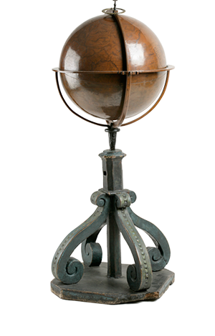

Terrestrial Globe
1542
Euphrosynus Ulpius
Copper, wood
Globe, Diam. 15 in. (38.1 cm), H. with stand, 43 in. (109.2 cm)
New-York Historical Society, Gift of John David Wolfe, 1872.22

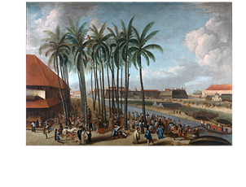

The Castle of Batavia, seen from West Kali Besar
ca. 1662
Andries Beeckman
Oil on canvas
56 3/4 x 82 1/3 in. (144 x 209 cm)
Tropenmuseum, Amsterdam, 118-167

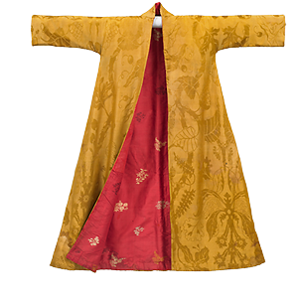

Man's Gown
English; ca. 1700-1720
Gold silk damask (likely Chinese; ca. 1690-1720); lining: red brocaded silk (likely Persian; ca. 1700-1720); collar and cuffs: red silk damask (English; ca. 1700-1720); wool padding
L. (center back) 58 in. (147.3 cm)
Cora Ginsburg LLC

Dutch New York
The Dutch New York section of the exhibition focuses on the Dutch presence in North America and especially that of New York City and Flatbush where the Van Varicks moved in 1686. This section features key treasures of the New-York Historical Society that trace the history of the Dutch founding of New Netherland, its eventual takeover by the British, and the mix of Dutch and English culture that predominated in the time of the Van Varicks.
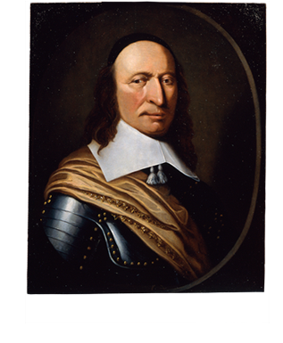

Peter Stuyvesant
n.d.
Artist unknown
Oil on wood panel
22 1/2 x 17 1/2 in. (57.2 x 44.4 cm)
New-York Historical Society, Gift of Robert Van Rensselaer Stuyvesant, 1909.2

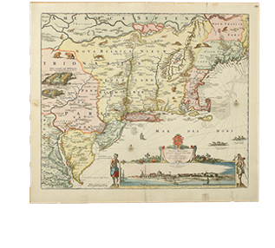

Novi Belgii novaeque Angliae nec non partis Virginiae tabula multis in locis emendata
After 1655 (possibly ca. 1682)
Printed by Nicolaes Jansz Visscher I (1618-1679) or Nicolaes Jansz Visscher II (1649-1702)
Engraving, handcolored
21 x 241/4 in. (53.3 x 61.6 cm)
New-York Historical Society

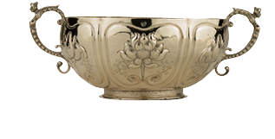

Brandywine Bowl (brandewijnkom)
ca. 1700
Benjamin Wynkoop (1675-1751)
Silver
H. 5 3/4 in. (14.6 cm), W. including handles 12 3/8 in. (31.4 cm)
Marks: struck twice at lip (center front and center back), maker's mark "W K / B" in a heart outline surround
Inscriptions: in block letters at lower center of one lobe, "P / C * M"; at opposite lobe, "E. D. P."; in script at center front, "H. C. de Peyster"
New-York Historical Society, Bequest of Catherine Augusta De Peyster, 1911.38

Margrieta's Inventory: A World of Goods
The hundreds of items detailed in Margrieta van Varick's inventory are explored in the next section of the exhibition. While we have not been able to trace the actual objects Margrieta possessed, this section features furniture, ceramics, silver, textiles, and everyday goods that are likely of the type that were owned by this Dutch family in late seventeenth century New York.
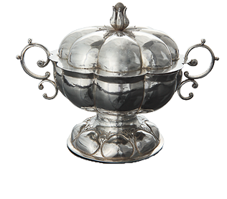

Covered Bowl
Batavia (present-day Jakarta, Indonesia), first quarter of the 18th century
Silver
5 1/4 x 7 1/4 in. (13.3 x 18.5 cm) including handles
Marks: none
Collection Gemeentemuseum, The Hague, 0154559

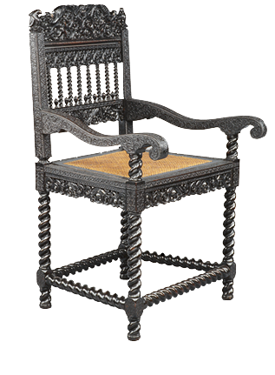

Armchair
Probably Coromandel Coast, India, ca. 1680-1720
Ebony, ebonized hardwood, ivory, ebonized walnut inner-seat frame with cane
42 x 24 x 19 1/2 in. (106.7 x 61 x 49.4 cm)
J. Paul Getty Museum, Los Angeles, 92.DA.24.3

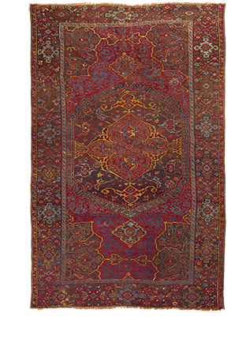

Medallion Ushak Carpet
Ushak, Turkey, 17th or early 18th century
Wool and cotton
144 x 92 in. (366 x 234 cm)
The Colonial Williamsburg Foundation, 1959-109

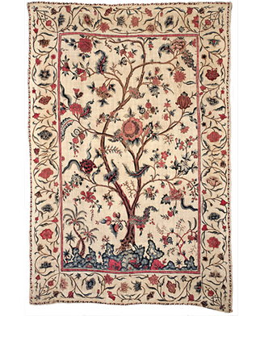

Palampore Wall Hanging or Bedcover
Southeast India, Coromandel Coast (present-day Andhra Pradesh), ca. 1720-40
Cotton, painted and mordant-dyed
78 1/2 x 52 1/2 in. (199.4 x 133.4 cm)
New-York Historical Society, Gift of Mrs. J. Insley Blair, 1938.1

The Van Varick Legacy: From Colony to Nation
The final section of the exhibition considers Van Varick's legacy, both material and cultural. Of particular interest here is a large selection of silver created by Peter van Dyck who married Margrieta's daughter Cornelia in 1715. Also featured here are portraits of Margrieta's descendents including her great- grandson Marinus Willett who was an important officer in the Revolutionary War and later a mayor of New York City.
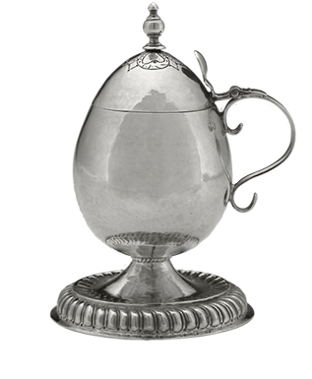

Mustard Pot
ca. 1705-15
Peter van Dyck (1684-1750)
Silver
H. 5 1/8 x Diam. base 3 3/8 in. (13 x 8.6 cm)
Marks: marked at lip near handle "PV/•D" (in a trefoil)
Yale University Art Gallery, Mabel Brady Garvan Collection, 1930.1332

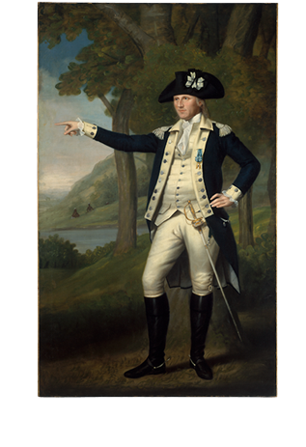

Marinus Willett
ca. 1791
Ralph Earl (1751-1801)
Oil on canvas
91 1/4 x 56 in. (231.5 x 142.2 cm)
The Metropolitan Museum of Art, Bequest of George Willett Van Nest, 1916 (17.87.1)

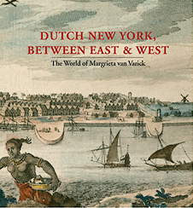

Dutch New York Between East and West: The World of Margrieta van Varick
Presented in conjunction with the 400th anniversary of Henry Hudson's voyage of discovery and celebrating the lasting legacy of Dutch culture in New York, this book explores the world of a fascinating woman, her family, and the possessions she accumulated over an eventful lifetime. Margrieta van Varick was born in 1649 in the Netherlands, but she spent many years at the extremes of the Dutch world-in Malacca on the Malay Peninsula and in Flatbush, now part of Brooklyn. She arrived in New York in 1686 with her husband, a Dutch Reformed minister, and set up a textile shop, bringing with her an astonishing array of objects from the Far East and Europe. Her shop goods, along with her household furnishings, were meticulously recorded in an estate inventory made after her death in 1695.
The inventory lay forgotten for more than two hundred years but was rediscovered in the twentieth century, pointing the way to new research into the histories of New York City, the Dutch overseas trading empire, women, and material culture. An intriguing selection of this ground-breaking research is presented in this volume. It has been edited by Peter Miller, Dean and Chair of Academic Programs at the Bard Graduate Center, and Deborah Krohn, Associate Professor at the BGC, with the assistance of Marybeth De Filippis, Associate Curator of American Art at the New-York Historical Society, who also pieced together Margrieta's life in the East largely from archival documents. Essays by leading scholars in the field-Joyce D. Goodfriend, Jaap Jacobs, Els Kloek, Ruth Piwonka, David William Voorhees, and Kees Zandvliet- illuminate aspects of Margrieta's world. An interview with renowned historian Natalie Zemon Davis conducted by Peter Miller considers the role of inventories in historical inquiry. Although to date it has been impossible to link specific objects to the items in Margrieta's inventory, representative objects have been judiciously chosen for the exhibition. They serve as springboards to discussions by a group of more than thirty leading curators and scholars, covering different areas of expertise, who have contributed insightful catalogue entries. The intense investigation of the past by this wide group of scholars holds up a mirror to present-day New York and serves as a reminder of a vanished world.
Published by The Bard Graduate Center: Decorative Arts, Design History, Material Culture / New York; The New-York Historical Society; and Yale University Press / New Haven and London.

Dutch New York Between East and West: The World of Margrieta van Varick
Edited by Deborah L. Krohn and Peter N. Miller with Marybeth De Filippis

Foreword
Susan Weber

Preface
Louise Mirrer and Linda S. Ferber

Chronology
Marybeth De Filippis and Margriet de Roever

Introduction: Seeking Margrieta
Peter N. Miller and Deborah L. Krohn

Chapter 1

The Dutch Overseas World in the Seventeenth Century
Kees Zandvliet

Chapter 2

Women of a Seafaring Nation: A Chapter in the History of the Dutch Republic, 1580-1700
Els Kloek

Chapter 3

Margrieta van Varick in the East: Traces of a Life
Marybeth De Filippis

Chapter 4

"It has pleased the Lord that we must learn English": Dutch New York after 1664
Jaap Jacobs

Chapter 5

A Portrait of Women in Seventeenth-Century New York
Joyce D. Goodfriend

Chapter 6

Flatbush in the Time of the Van Varicks
David W. Voorhees

Chapter 7

Margrieta van Varick in the West: Inventory of a Life
Ruth Piwonka

About an Inventory:
A Conversation Between Natalie Zemon Davis and Peter N. Miller

Catalogue of the Exhibition
Appendix:
Will of Rudolphus van Varick
Will of Margrieta van Varick
Inventory of the Estate of Margrieta van Varick
Glossary
Supplementary Sources
Bibliography
Index

